NACA fitting results

**Simulated data with noise:**

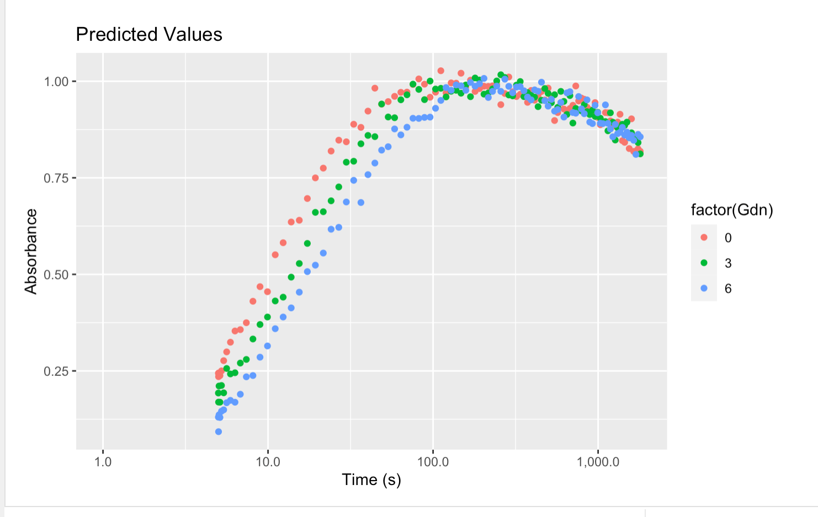

**Fit simulated data with same priors:**

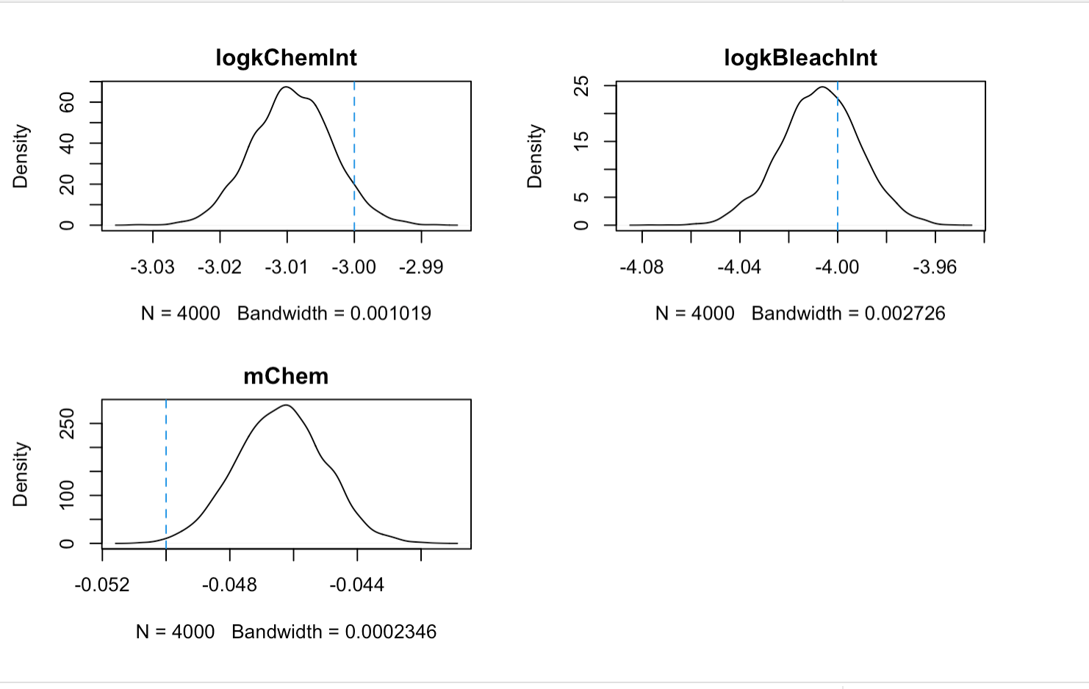

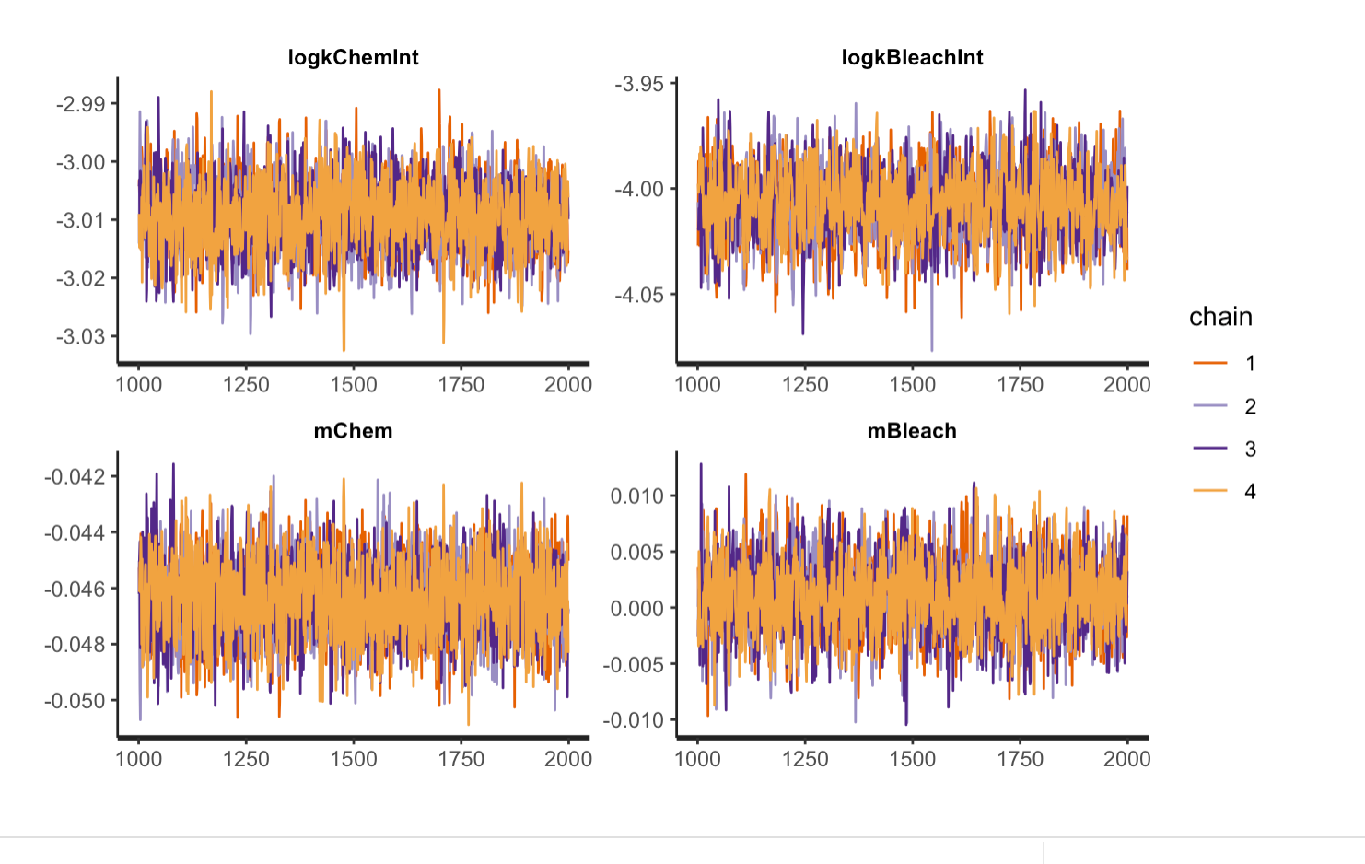

**Fit simulated data with different priors:**

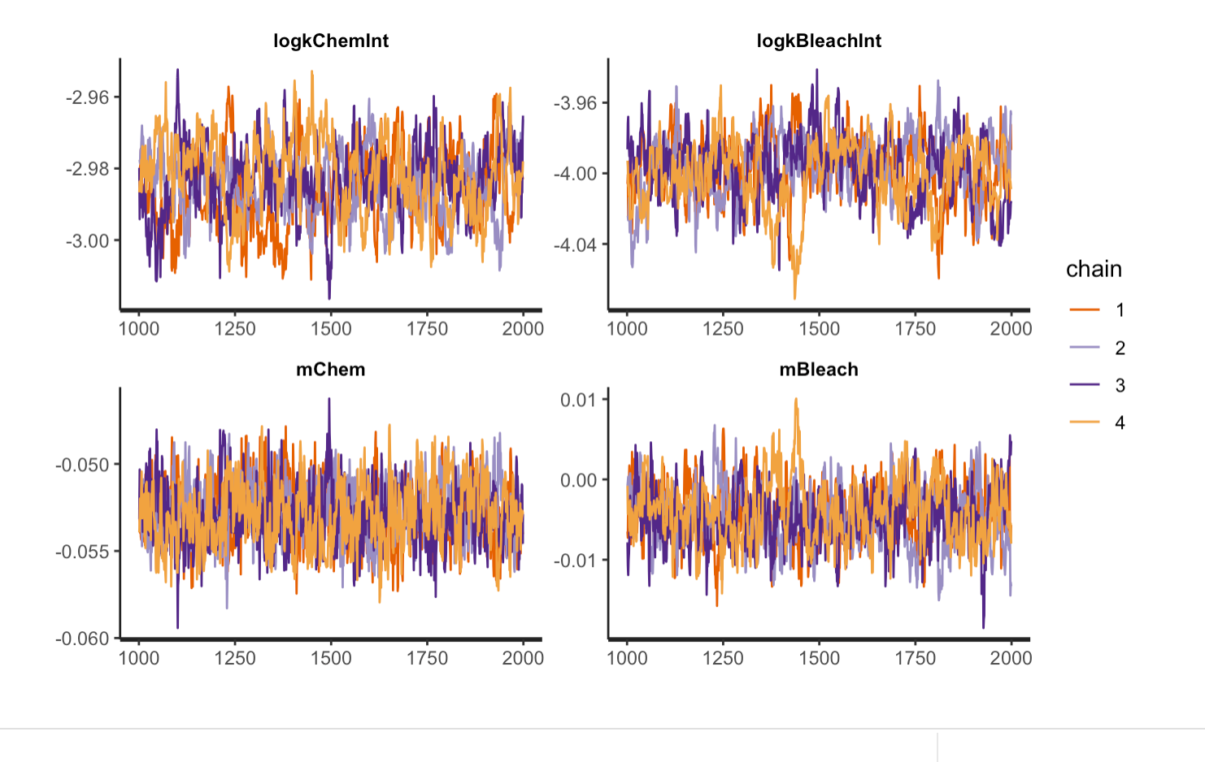

**Fit experimental data (two runs):**



